Computer Language Diagrams

Method Objects in a Diagram
The principle of method objects is explained in the article Method Objects. This article demonstrates their expression in diagrams.

Parameters of a method are expresed as circles inside a square.

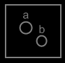

The circle represent the method. The squares represent the parameters.

When a method is called, objects are filled in as parameters for the method. This means the object symbols inside the call will become pointers to objects.



The diamond represents the call. The circles represent the parameters, and the lines represent pointers to the objects. The objects themselves are not shown in the diagram above.

A call is also considered a call upon objects, which would change the notation to:

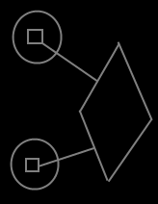

The diamond is the call, the circles are the objects called upon, the squares both represent the definition of the method, so the definition of the method is displayed twice: once for each object.

However, a hybrid notation is used to emphasize the interchangability between object methods and method parameters. It also makes the objects available inside the method call, as opposed to the notation of a call upon objects.



This is an implicit display, because a connection between two symbols usually means, that they are the same thing, but in this implicit notation an object is tied to a method. An object and a method are never the same thing. However, this notation is a clear depiction of the interchangability between method parameters and the methods of an object.

See also: Method Objects, Method Parameters in a Diagram, Methods in a Diagram

Author & Copyright: Jan-Joost van Zon Date: May 24, 2008 – May 24, 2008 Location: Oosterhout, The Netherlands Status: Finished

